Curiosity Weekend #1: A Prelude to Startup Day
On 11th January, the IEDC LBS College of Engineering Kasaragod, in collaboration with Kerala Startup Mission, organized the first-ever Curiosity Weekend at Leap Coworks. The event, held in the lead-up to Startup Day on 15th January, aimed to inspire innovation and foster collaboration among young minds.
The program welcomed 30 participants from LBS College of Engineering Kasaragod and Chattanchal Higher Secondary School, who were randomly divided into teams. Each team worked to design and build a line follower robot, combining creativity, technical knowledge, and teamwork.

Event Highlights:
- Team-Based Challenge: Participants collaborated to construct and program line follower robots, pushing their technical and problem-solving abilities.
- Guided Mentorship: Experts provided hands-on guidance throughout the challenge, ensuring a learning-rich experience.
- Feedback and Learning: Teams actively discussed challenges faced during the process, sharing insights and lessons learned to refine their approaches.
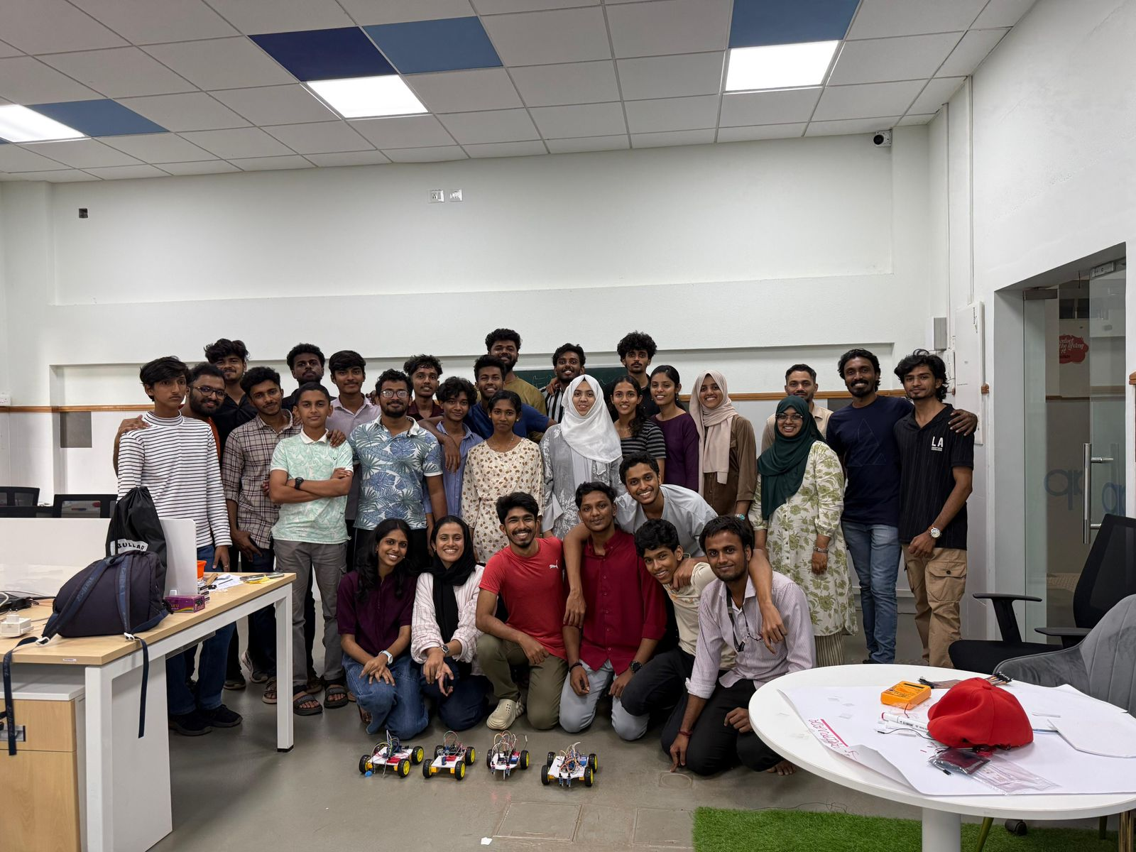
Decisions Made for Future Curiosity Weekends:
The event concluded with a lively discussion where participants shared feedback and ideas for future editions. Key decisions included:
- Line Follower Robot Competition: To evolve the current project into a competitive format for the next Curiosity Weekend.
- Event Promotion through Blogs: To document and share the experiences and insights from the event, reaching a wider audience.
- Exploration of New Domains: To diversify the scope of activities by introducing challenges in areas such as AI, app development, and creative problem-solving.
- Work-Integrated Gaming: To incorporate game-based elements that seamlessly integrate learning and fun.

Impact:
The event set the tone for Startup Day celebrations by inspiring participants to think creatively and work collaboratively. Curiosity Weekend #1 not only provided a platform for practical learning but also established a roadmap for future initiatives aimed at fostering innovation and engagement.

